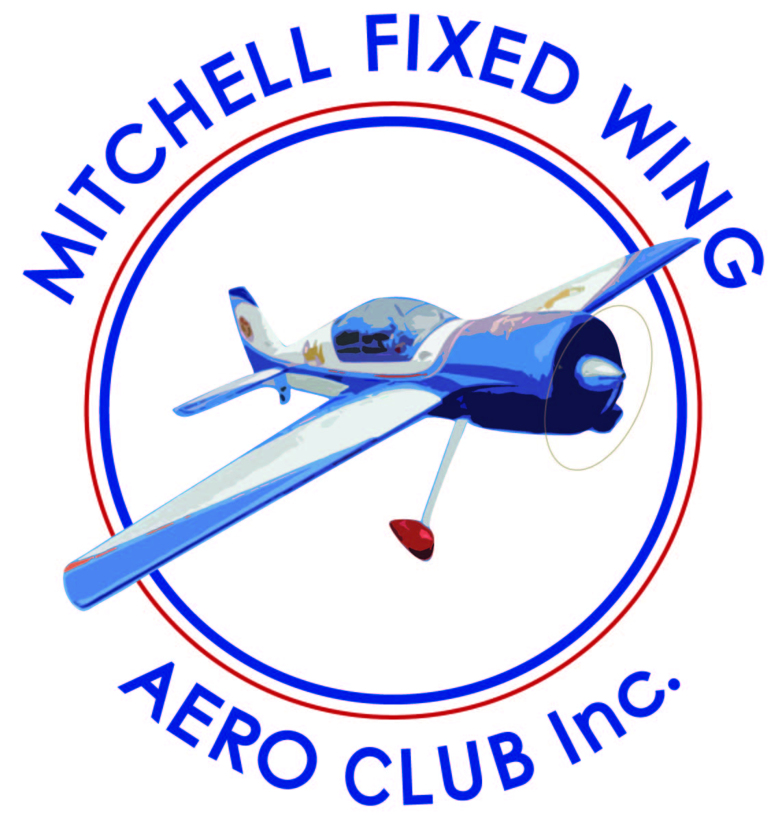
Membership Application – 2021/2022
SURNAME: __________________________________ ____________________________________________

GIVEN NAME: ____________________________________________________________________________

ADDRESS: ________________________________________________________________________________
STREET TOWN POST CODE

PHONE:___________________________________________________________________________________
HOME MOB WORK

PENSIONER NUMBER: ___________DATE OF BIRTH: ________ WINGS: _________________________

EMAIL ADDRESS:__________________________________________________________________________

AUS NUMBER:

CLUB FEES:
The following fees are calculated from the commencement of the financial year end, to 30th June
VMAA/MAAA  $144 | MFWAC  $66 | TOTAL  $210 | AFFILIATE FEES  $66.

Membership fees if sent to Mitchell Fixed Wing Aero Club – Registrar
John Blackwell 17 Tallarook Street Seymour 3660
I request that I be granted membership of: MITCHELL FIXED WING AERO CLUB Inc.. I understand and accept that MITCHELL FIXED WING AERO CLUB Inc., reserves the right to refuse membership.
On acceptance of my application …..
I AGREE TO ABIDE BY THE RULES OF THE ASSOCIATION. AND THE RULES OF THE CLUB CONSTITUION.

GMCU BSB 803078 AC/NO 23479
Direct Debit number: 100070799 please make sure your name is included on payment reference.

Signature: ___________________________________________________
Proposed by:___Barry Dunn_____________________________________ Date: _________

